“LISTS OF STUFF” Project - Part 2 (After 20 movies have been entered)
YOUR ASSIGNMENT

Numbers to Calculate (and Functions to Use)
- Total number of movies listed (“COUNTA”)
- Date of newest movie listed (“MAX”)
- Date of oldest movie listed (“MIN”)
- Number of times that one actor (e.g. George Clooney) appears in your list (“COUNTIF”)
- Number of times that one director (e.g. Peter Jackson) appears in your list (“COUNTIF”)
- The highest rating that you gave (“MAX”)
- The lowest rating that you gave (“MIN”)
- The median rating that you gave (“MEDIAN”)
- The average rating that you gave (“AVERAGE”)
- The number of times you gave the highest rating (“COUNTIF”)
- The number of times you gave the lowest rating (“COUNTIF”)
- The number of times you gave the median rating (“COUNTIF”)
- The number of times you gave the average rating (“COUNTIF”)

Mr. Rich's Sample Finished Product
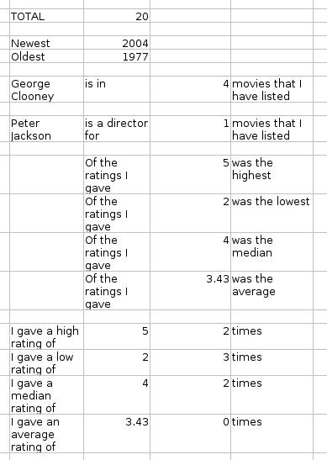
You calculate the red areas. Marks are based on having the right formula.

Here's a screen capture of my numbers. Yours may vary.

You will need to choose your own actor or director for the search.
I recommend copy-and-paste so that the spelling is exactly the same.

Step-by-Step Instructions (for Question #1 above)

Now that the 20 movies have been entered, it's time for us to use some SPREADSHEET functions to calculate a few numbers.

First, let's total the movies that have been entered. To do this, go to the bottom of the data (movie list) and click to select a cell.
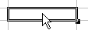

Once the cell is highlighted (as above) then enter the word “TOTAL” and hit ENTER.
Now click on the “AutoPilot: Functions” button. It should be located here:
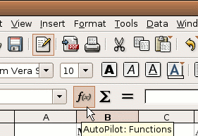

Then the “AutoPilot: Functions” popup window should appear, like this:
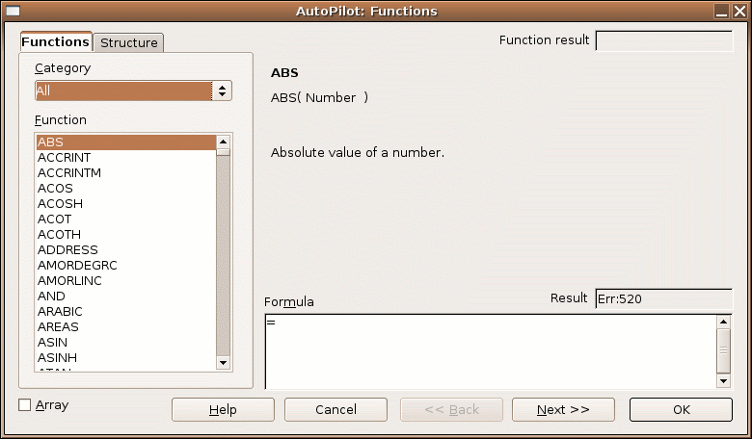

From this list of functions, scroll down down down and choose “COUNTA”.
The popup window should now look like this:
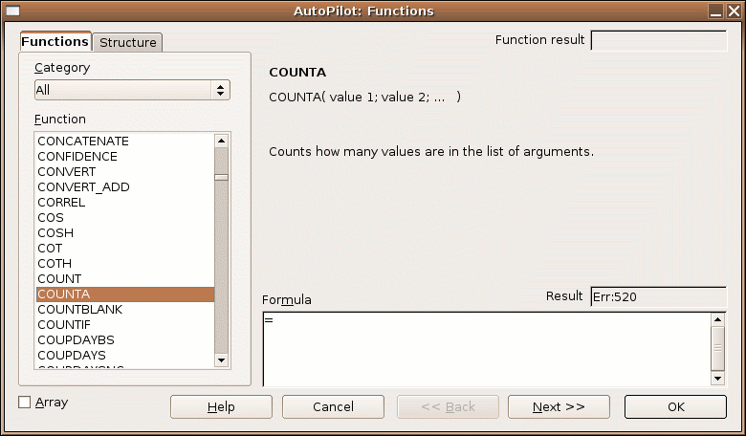

Double-click on “COUNTA” to change the popup window to this:
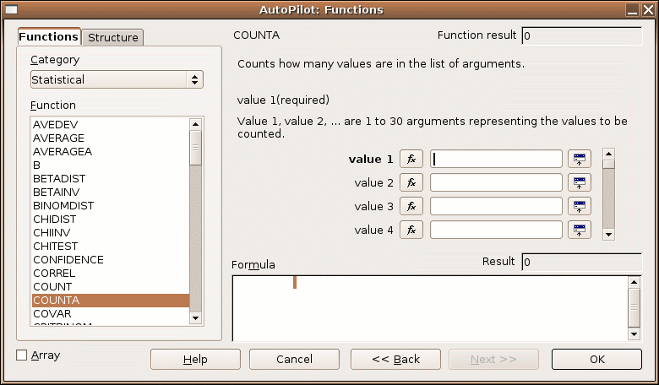

Now we need to select the range of cells that we will count. To start this process, click the “Shrink” button that looks like this:
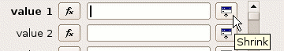
Once clicked, the “Shrink” button changes the popup window to this:
Now, it's time for you to click-and-drag over the cells you want to count. In this case, we want to count all the Movie Names (or Movie Titles) that we've created. So, we drag the mouse over the Movie Names to create a red (or blue) box around our cells to count.
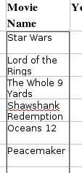

Once you let go of the mouse button, the popup window should look like this. Your column letters or row numbers may be different.
Now, once this is set, click ENTER on your keyboard.
Then, click OK on the popup window.

You should now see the total number of movies in your list displayed in that cell.
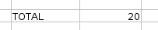

Now, here are the list of questions which need to be answered. The graphic below shows the results from my creation. You will probably have different results from your calculations.

***** End of Question #1 Instructions *****

(Pages below are to answer CountIf questions.)

Using the COUNTIF Function
The COUNTIF function is very similar to the above functions where you have to specify the RANGE using the SHRINK button.

However, you also need to specify the CRITERIA (also using the SHRINK button). The CRITERIA is the cell that you want to look for.

Let's start from the beginning.
- First, type in what we are looking for. In this case, we are looking for the number of times that an actor named “Mike Myers” appears in our list of actors.
- We want to copy the exact name into the proper cell, have supporting cells so that the resulting sentence will make sense, and then have a blank cell in the middle where we will enter the formula.

- Then, click the AutoPilot: Functions button and choose the COUNTIF function (with a double-click).
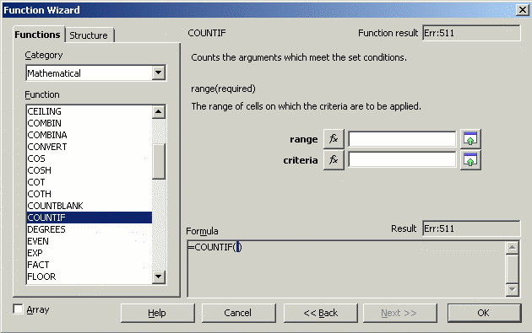

- Then click the SHRINK button beside the word “Range”.

- Then drag your mouse over all the actor's names (all 4 columns, from top to bottom). Once completed, press ENTER.
- Next, click the SHRINK button beside the word “Criteria”.
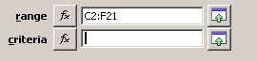
- Then click once on the cell that contains the actor's name. (In our case, we will click on a cell that has “Mike Myers” typed in it.)
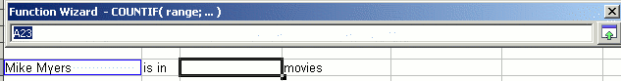

- Next, click the OK button in the AutoPilot: Functions window.
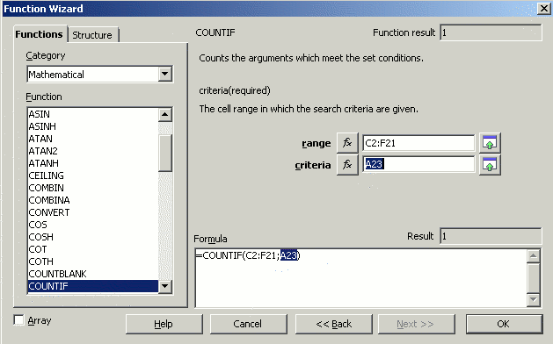
Your result should look like this:

Of course, you will choose a different actor, and your list of movies will no doubt include a different number of movies in which this actor appears. However, the formulas and methods used will be the same.

So, following this pattern, go back to the list of questions and follow the COUNTIF proceedure for all the other COUNTIF questions.

